Parameters of KMeans in sklearn:

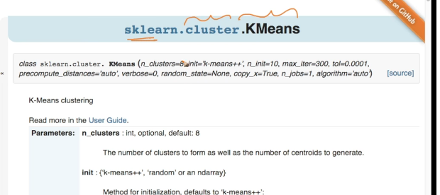

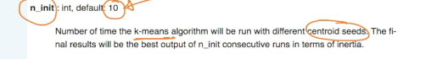

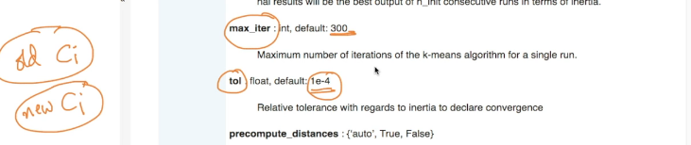

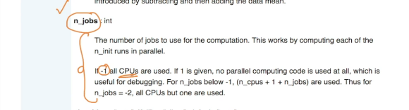

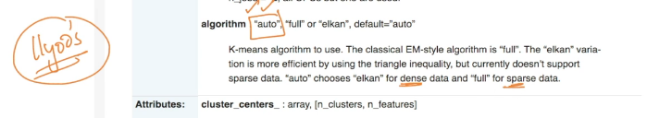

Some code sample:

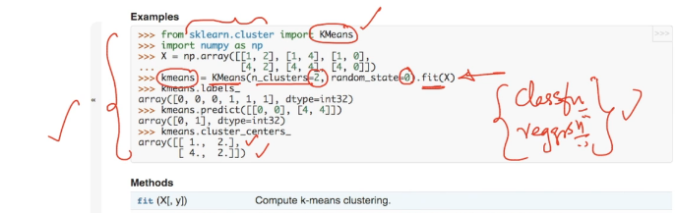

For K-Medoids do google search and you will find some code implementation done by various people.

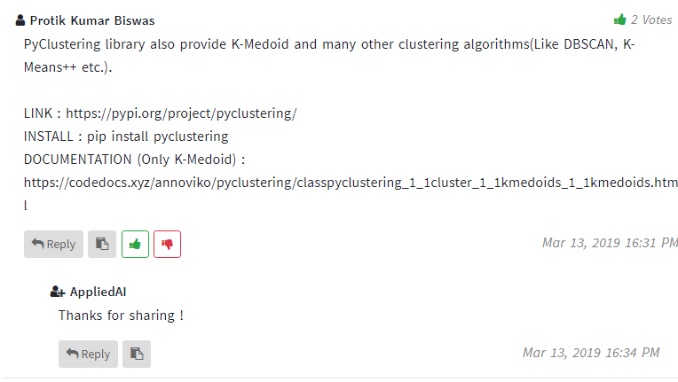

https://codedocs.xyz/annoviko/pyclustering/classpyclustering_1_1cluster_1_1kmedoids_1_1kmedoids.html